|  |  |
| --- | --- |
| **Project title:**  EnDev – African Biodigester Component (ABC)  **Country:**  Kenya  **Subject of the tender procedure:**  Results Based Reimbursement Facility for Installation of Small-scale Biodigesters | **Transaction number:**  83427345 |



**Application template for the Result-Based Reimbursement Facility – ABC Kenya**

**The African Biodigester Component (ABC)**

Funded by the Dutch Ministry of Foreign Affairs (DGIS), the Danish International Development Agency (DANIDA) and the European Union, the African Biodigester Component (ABC) aims to support the growth and sustainability of a commercial biodigester sector in Sub-Saharan Africa. The intervention will result in the installation of at least 50,000 small scale biodigesters by 2025 across Burkina Faso, Kenya, Mali, Niger and Uganda providing energy access for at least 250,000 people. ABC is managed by RVO (the Netherlands Enterprise Agency).

The ABC project in Kenya, herein referred as ‘ABC Kenya’ implemented in 2022 - 2025, aims at facilitating a shift of the biodigester market from its pioneering to the expansion phase with focus on the installation of over 20,000 small-scale and 250 medium scale biodigesters. The project is implemented by a consortium of GIZ and SNV in partnership with ABPL, the African Bioenergy Partnership Limited (ex-KBP – Kenya Biogas Programme).

This will be achieved by means of a well-balanced mix of demand-side, supply side, financing and enabling environment interventions, geared at boosting demand and supporting small scale and medium scale biodigester companies in acquiring more clients. A Result-Based Reimbursement facility for small-scale biodigesters will be the core instrument of the African Biodigester Component (ABC). Through the provision of Result-Based Reimbursements, the Project expects to provide the last push needed for the biodigester market to reach a critical mass of clients within Kenyan farmers. This is expected to enable suppliers of small-scale biodigesters to achieve economies of scale, the market to be firmly rooted in the expansion phase and become self-sustainable.

**Overview of the Facility**

The Results Based Reimbursement Facility of ABC Kenya aims at providing **results-based reimbursements** for **pre-agreed results** for eligible biodigester enterprises and individuals **operating, having physical presence and legally registered in Kenya** as per theapproved ABC Kenya proposal.

The results in this context shall be the number of biodigesters systems installed by the participating contractors. The payments for the results are done after verification by an Independent Verification Agent (IVA) of the ABC Project (KPMG).

The project targets to achieve the installation of over 20,000 small scale biodigesters during the project implementation through participating biodigester enterprises. The aim of the results-based reimbursements shall be to facilitate the participating enterprises to deliver the targets but also support the companies to mitigate the temporary market barriers.

The projected sales/installation targets are grouped into 3 quotas and the expected duration during which the sales targets shall be achieved. The payments of the results is also pre-specified for each sales quota and the amounts indicated below are the **maximum possible** **per sales quota**.

|  |  |  |  |
| --- | --- | --- | --- |
| Sales Quota | Expected duration for achievement*[1] | Number of Biogas Plants | Payment per installed digester (EUR/KES)**[2] |
| Quota 1 | January 2023 – December 2023 | 8,000 | Up to EUR 100 / up to KES 12,000 |
| Quota 2 | January 2024 – December 2024 | 7,000 | Up to EUR 75 / up to KES 9,000 |
| Quota 3 | January 2025 –  August 2025 | 5,020 | Up to EUR 60 / up to KES 7,200 |
| Total |  | **20,020** |  |

The reimbursements for the results shall only be made subject to a successful verification process by the Independent Verification Agent (IVA) of the ABC project. The IVA of the project is KPMG and in case of any changes the contractors shall be informed accordingly.

An **operational manual** shall be provided to the selected contractors to provide guidance and requirements for the facility.

**Purpose of the assignment**

GIZ invites biodigester enterprises to submit the filled-in **application template** which contains the **financial proposal** (question 4.) together with the following statutory documents:

* For bidding enterprises:
  + Certificate of Incorporation
  + CR12 Certificate
  + Tax Compliance Certificate
* For bidding individuals:
  + Kenya Revenue Authority PIN Certificate.

The financial proposal is based on the number of biodigesters the enterprises intend to sell as well as associated conditions (sales beyond current baseline, functionality rate, presence / absence of double compost pit and sales in low sales/arid counties). The incentive total amount has been fixed in consultation with the different stakeholders.

The applicants shall propose how they will contribute to the project biogas installation targets in their application template below. Each company shall be required to propose realistic targets that shall be potentially achieved during the three years of project implementation. The targets of installed biogas plants inform the financial proposal.

**Scope and description of the tasks**

GIZ is seeking to engage with Kenyan registered biodigester enterprises and individuals, herein referred as the contractors or bidders, to build / install over **20,000** small scale biodigesters (0 to 50m3). GIZ will engage up to **35 biodigester enterprises** who meet the eligibility criteria for participating in the assignment. The biodigester enterprises **could bid for only one of the four lots** presented below. Reaching the different quota depends on the sales of all companies in the 4 lots. GIZ will indicate every month if the quota is reached.

|  |  |  |  |  |  |  |  |  |  |
| --- | --- | --- | --- | --- | --- | --- | --- | --- | --- |
| Lot | Type of biodigester company | Number of companies to be selected | Quota 1 (Reimbursement up to 100€ per verified biodigester) | | Quota 2 (Reimbursement up to 75€ per verified biodigester) | | Quota 3 (Reimbursement up to 60€ per verified biodigester) | | Total verified sales |
| Expected verified sales / company | Total verified sales | Expected verified sales per company | Total verified sales | Expected verified sales per company | Total verified sales |
| 1 | More than 1200 sales / year | 1 | 2400 | 2400 | 2200 | 2200 | 1500 | 1500 | 6100 |
| 2 | 200 to 1200 sales / year | 6 | 470 | 2820 | 450 | 2700 | 340 | 2040 | 7560 |
| 3 | 100 to 200 sales / year | 8 | 150 | 1200 | 140 | 1120 | 100 | 800 | 3120 |
| 4 | 0 to 100 sales / year | 20 | 79 | 1580 | 49 | 980 | 34 | 680 | 3240 |
| Total | | 35 | 8000 | | 7000 | | 5020 | | 20020 |

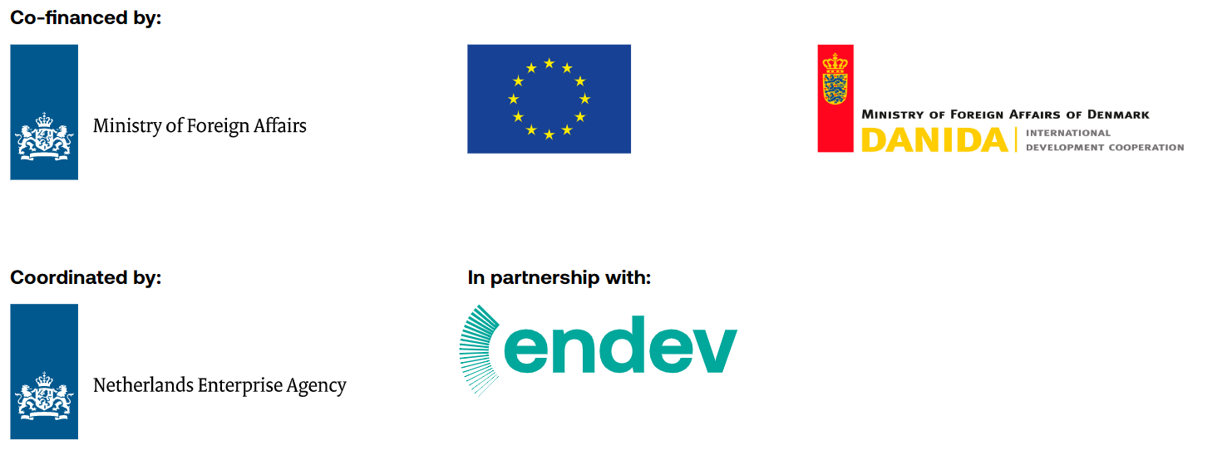

**Start to fill in from here – the grey parts as well as all the questions on this page**

|  |  |
| --- | --- |
| Name of the contractor: |  |

Address:

|  |
| --- |
|  |

Type of contractor (only check one):

Enterprise

Individual

|  |  |
| --- | --- |
| 1 - Number of staff to deliver the tasks to be performed: | Staff |
| Of which women: | Women employees |

2 - Capacity to properly collect and report data on the biodigester sales and customers (using the Taroworks application). *Selected companies will be trained on the tool by GIZ:*

Yes

No

**Checklist:**

If you are an enterprise, please attach to your application the 3 documents below:

Certificate of Incorporation

CR12 Certificate

Valid Tax Compliance Certificate

If you are an individual / sole proprietor please attach to your application the 1 document below::

Kenya Revenue Authority PIN Certificate

Number of biodigesters sold:

|  |  |
| --- | --- |
| In 2020: |  |
| In 2021: |  |
| In 2022: |  |

For which lot are you bidding (**you can only bid to one lot**):

Lot 1 - More than 1200 sales / year

Lot 2 - 200 to 1200 sales / year

Lot 3 - 100 to 200 sales / year

Lot 4 - 0 to 100 sales / year

**Business Plan**

1. Strategy 10%

|  |
| --- |
| *Please briefly describe your company and explain your overall strategy as well as how the support provided through the results-based reimbursement facility will help you to achieve this overall strategy. How do you intend to deliver the assigned results?* |

1. Learning and innovation 20%

|  |
| --- |
| *Please describe your capacity (including technical background of the responsible person(s)) in collecting data regarding biodigesters sales and clients and how it informs you strategy and promote scaling-up. Can you outline measures that will be used to increase sales over the different quotas?* |

|  |
| --- |
| *Please let us know if you want to explore any innovative ideas with the project team. This may include innovations in business models, marketing approaches, access to consumer finance, bioslurry utilisation, productive use of biogas etc Can you share with us any lessons learned/experiences from your scope of work?* |

1. Project management 30%

|  |
| --- |
| *Please indicate specific interventions to facilitate the achievement of the results/targets of the project. These interventions shall include but not limited to:*   * *Sales and installation of biodigesters* * *Marketing and consumer education for biodigesters* * *Establishing and expanding last mile distribution channels* * *Quality assurance and after sales support* * *Consumer financing* * *Other relevant activities* |

|  |
| --- |
| *Please describe your approach and how you want to collaborate with the GIZ Project in delivering the pre-agreed sale targets. You can add a brief operational plan for this assignment. Please describe how you ensure you are on track for delivering the pre-agreed sale targets. Please indicate to us the technical background of the team.* |

1. What are the proposed sales targets for each quota and which lot did you applied for? 20%

|  |  |  |  |
| --- | --- | --- | --- |
| Sales Quota | Proposed Period | Proposed Number of Biodigesters | Reimbursement per biodigester (up to EUR) |
| Quota 1 | Jan-Dec 2023 |  | 100 |
| Quota 2 | Jan-Dec 2024 |  | 75 |
| Quota 3 | Jan-Sept 2025 |  | 60 |
| Total | |  |  |

**Note:**

Lot 1 - More than 1200 sales / year

Lot 2 - 200 to 1200 sales / year

Lot 3 - 100 to 200 sales / year

Lot 4 - 0 to 100 sales / year

1. Sustainability requirements 10%

|  |
| --- |
| *Which measures will be put in place to ensure the business is not affected after the end of the Reimbursement facility? Are your activities structured in a way that reduces unintended negative effects and promotes gender equality? How do you ensure all your staff is under contract? Do you plan to target specific low sales / arid counties (Garissa, Lamu, Mandera, Wajir, Marsabit, Turkana, West Pokot, and Isiolo)?* |

1. Historical sales 10%

What is the history of the company in terms of sales? Fill in the table below:

|  |  |  |  |
| --- | --- | --- | --- |
| **Period** | **2020** | **2021** | **2022** |
| **January – March** |  |  |  |
| **April – June** |  |  |  |
| **July – September** |  |  |  |
| **October – December** |  |  |  |
| **Total** |  |  |  |

1. *The expected duration is not fixed for each sales quota. The advancement from one sales quota to the next is triggered by the achievement of the sales targets by all the companies regardless of the expected duration*
2. KES equivalent based on December 2022 exchange rate and may change due to exchange rate fluctuations.