Call for Expressions of Interest (EoI) for Biogas Enterprises in Kenya to participate in a Results Based Financing Facility

Opportunity
Energising Development Kenya Programme (EnDev Kenya), through the EnDev - African Biodigester Component (ABC), aims to support the growth and sustainability of a commercial biodigester sector in Kenya hence enhancing market development and access of good quality small scale biogas digesters for domestic and productive use. A Result-Based Finance (RBF) facility will be the core instrument of the project for small-scale biodigesters. EnDev - ABC is therefore inviting biogas enterprises through this Call for Expressions of Interest (EoI) to participate in the RBF facility.
Target companies
This opportunity targets Kenyan registered biogas companies/enterprises operating in a commercial/market-based approach.
Eligible technologies (including associated appliances accessories)
- Fixed biodigesters
- Prefabricated biodigesters
Call
The call for EoI for 2021 commences on 1st April 2022 and applications are accepted from interested companies/organisations on a rolling basis until 20th May 2022 (extended). GIZ shall evaluate the EoI and carry out due diligence process and thereafter the applicants will be informed on their eligibility to participate in the project. More information on this Call can be accessed in https://endev.info/calls/.
Application
Interested applicants shall be required to fill in an application template available at https://endev.info/calls/ and submit via email to info-energyke@giz.de. The application deadline is 20th May 2022 (extended).
Virtual Orientation workshop
EnDev ABC shall organise a virtual orientation for this call for EoI on Thursday 14th April 2022 (already passed). Interested applicants needing more orientation on the EoI should register for this meeting by 10th April 2022 (already passed) via mail to info-energyke@giz.de. An orientation on the call for this EoI will be elaborated during the workshop.
For applicants who are unable to attend the virtual workshop on 14th April 2022 (already passed) and have questions on the call for EoI, please contact us on info-energyke@giz.de by 16th May 2022 to organise one on one clarification.
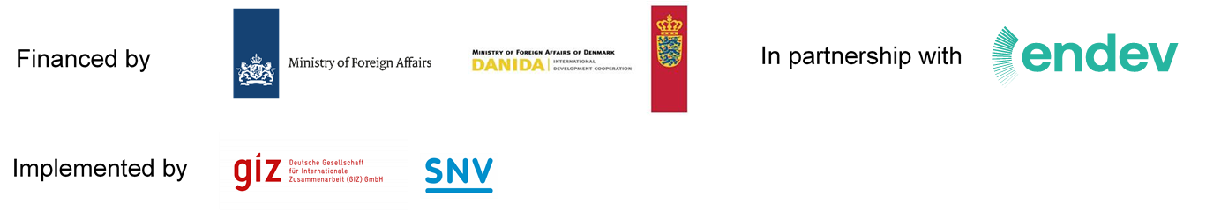
Note that you will be required to provide consent for sharing your personal details for workshop registration and the application.

